CMSC424 Term Project

U.S. Presidential Election Result Database

Yufan Fei, Yufang Feng

**Table of Content**

1. **Introduction** --- 3
   1. **Description of the purpose of the document**
   2. **Purpose of the project**
2. **The sites and sources being utilized for the system** --- 3
3. **Assumption** --- 3
4. **Top-level information diagram** --- 4
5. **The list of tasks** --- 5
6. **The data documents that carry data between tasks**  --- 9
7. **ETL Task** ---11
8. **E-R Model** ---14
9. **Relation Break Down in BCNF Form** ---15
10. **Task Emulations** ---16
11. **Progress Report on Web Server Build up** ---20
12. **Interactive User Interface** ---21
13. **User Manual** ---22
14. **Limitations and possible improvements** ---27
15. **Appendix** ---28
    1. **Description of purpose of the document**

The purpose of this document is to provide detailed requirement and design specifications as well as to describe the implementation process and result for the Presidential Election Data Project. In this document, there is a description of how we performed the ETL (Extract-Transform-Load) tool and process, a description of the design documents and activities within the project, the function of the design the development phases.

* 1. **Purpose of the project**

The first purpose of the system is that to learn and practice in the ETL process which included collecting data from the internet (extract), organize and clean the data (transform), and load into to our designed database in an organized manner (load). After establishing a reliable database, we will run queries on the database to get various aspects of information the user needs and an interactive web server to provide limited knowledge to the user with customized variables among queries.

1. **The sites and sources being utilized for the system**

--- Wikipedia/poll

The U.S poll wiki page synchronize almost all of the U.S presidential result starting from 1936, which is the first year when the presidential poll officially launch.

--- archives.gov

The National Archives and Records Administration preserves U.S. government records, manages the Presidential Libraries system, and publishes laws, regulations, Presidential, and other public documents. It provides vote details per year from state view as well.

1. **Assumptions about the system**

The major limitation of the system is that as designers, we didn't have any web server experience before, such that loading data into the database became extremely difficult at first, until Fei figured out using his R background to tackle the data manipulation task.

1. **The top-level information flow diagram**

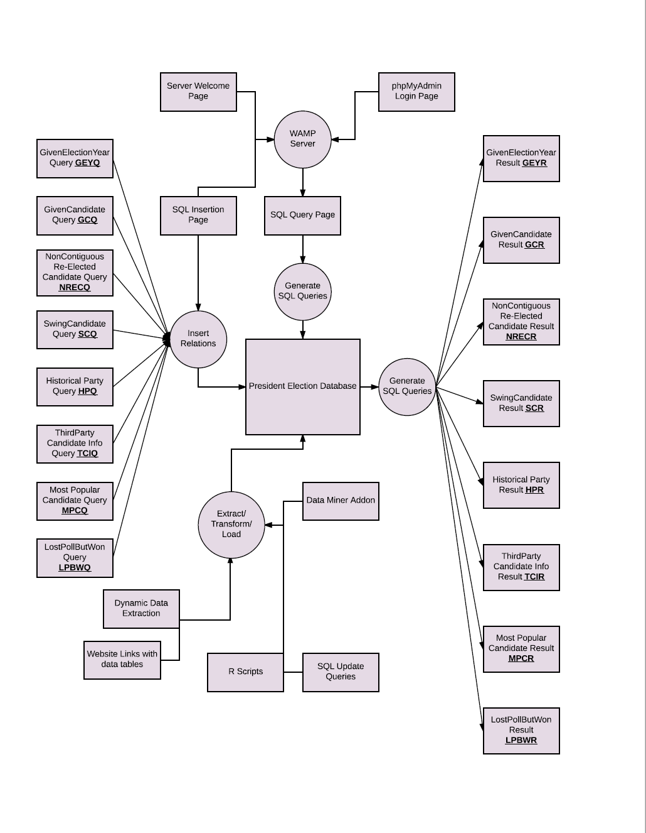

1. **The list of tasks**

* 1. *Build a Server*

**TASK NUMBER**: BAS

**TASK NAME**: Build a Server with MySql installed that allows users to access from anywhere

**PERFORMER**: EC2 Apache Server

**PURPOSE**: Create the server for backend and frontend jobs.

**ENABLING COND**: User accessing the web interface.

**DESCRIPTION**: find a remote server that hosts our website and the database

**FREQUENCY**: Once finished the job

**DURATION**: Very short

**IMPORTANCE**: Critical

**MAXIMUM DELAY**: 10 seconds

**INPUT**: None

**OUTPUT**: Welcome Page

**DOCUMENT USE**: WIFWF: Web Interface Welcome Form

**OPS PERFORMED**: Generation of welcome page, send it to the user and wait for user action.

**SUBTASKS**: None

**ERROR COND**: If A/TServer == busy, then Process=TimeOut.

* 1. *Web pages Research Task*

**TASK NUMBER**: WPRT

**TASK NAME**: Web Pages Research

**PERFORMER**: Presidential Election Database Designers

**PURPOSE**: Research on the rules of US election, and different statics needed for the database. And filter out what might be useful for us.

**ENABLING COND**: To populate the Presidental Election Query Generator.

**DESCRIPTION**: Research the internet

**FREQUENCY**: As often as necessary

**DURATION**: Varies

**IMPORTANCE**: Critical

**MAXIMUM** **DELAY**: N/A

**INPUT**: Web queries

**OUTPUT**: Index of queried results

**DOCUMENT USAGE**: Web-based search engines

**OPS PERFORMED**: Researching and bookmarking websites and/or pages with Historical presidential election data

**SUBTASKS**: None

**ERROR** **COND**: None

* 1. *Creating tables and Make sure it fits BCNF*

**TASK NUMBER**: CTAMSIF

**TASK NAME**: Web Pages Research

**PERFORMER**: Presidential Election Database Designers

**PURPOSE**: Research on the rules of US election, and different statics needed for the database. And filter out what might be useful for us.

**ENABLING** **COND**: To populate the Presidental Election Query Generator.

**DESCRIPTION**: Research the internet

**FREQUENCY**: As often as necessary

**DURATION**: Varies

**IMPORTANCE**: Critical

**MAXIMUM** **DELAY**: N/A

**INPUT**: Web queries

**OUTPUT**: Index of queried results

**DOCUMENT** **USAGE**: Web-based search engines

**OPS PERFORMED**: Researching and bookmarking websites and/or pages with Historical presidential election data

**SUBTASKS**: None

**ERROR** **COND**: None

* 1. *ETL Task*

**TASK NUMBER**: ETLT

**TASK NAME**: Extract, Transform, and Load Task

**PERFORMER**: R script, SQL update query, DataMiner and PHPMyAdmin

**PURPOSE**: To extract data, transform or reformat it and load it into the database

**ENABLING** **COND**: The creation of the database and any addition of data or updates to the database.

**DESCRIPTION**: This tool (DataMiner) extracts specific data from a web page, and load it into a CSV table.

**FREQUENCY**: Once for the creation of the database and during any updates.

**DURATION**: Varies

**IMPORTANCE**: Critical

**MAXIMUM** **DELAY**: N/A

**INPUT**: A selected web page

**OUTPUT**: Data into a relation in the database

**DOCUMENT USE**: HTML documents and

**OPS** **PERFORMED**: Data extraction, data transformation, and data loading.

**SUBTASKS**: Web pages Research

**ERROR** **COND**: None

1. **The data documents that carry data between tasks**

|  |
| --- |
| Query for a given Election Year  Election Year  President name  Main Opponent  Vice President  Party Affiliation  Poll Results |

|  |
| --- |
| Query for a given President/Candidate  President name  Election Year  Main Opponent  Vice President  Party Affiliation |
| Candidate Name  Election Year  Candidate Electoral Vote |

|  |
| --- |
| Query for Re-elected on non-contiguous times  President name  Term1  Term2 |

|  |
| --- |
| Query for Swing Candidates  Election Year1  Election Year2  President/MainOpponent name  Party Affiliation of Year1  Party Affiliation of Year2  Election Result of Year1  Election Result of Year2 |

|  |
| --- |
| Party Historical Query  Party Name  Electoral Vote  Party Vote  Win Counts |

|  |
| --- |
| Third Party Candidate Info Query  Election  Name  Party  Election Result |

|  |
| --- |
| Most Popular Candidate Query  Year  Name  Popular Vote Number  Party Affiliation |

|  |
| --- |
| Lost Poll But Won Election Query  Year  President Name  President Poll Rate  Opponent Name  Opponent Poll Rate |

1. **ETL Task**

A database system refers to a data management warehouse and hence, requires input data in a formatted way. Data used for this President Election Database are extracted from U.S Archives and Records Administration - U.S Electoral College. We would use PED and USEC afterward for simplicity sake.

* 1. *The Web Data Extraction Procedure*

USEC, as the major data source of the PED, keeps information of the electoral college box score from 1792 to 1996 completely. From a designer’s perspective, it is essential to choose a highly effective and repeatable measure in extracting required information. Thus, the Data Miner Addon provides the best tradeoff between customized data extraction and clarity. The backend users can select the bookmarked sites and set up XPATH traits accordingly, which greatly enhance the accuracy of data being filtered. This is accomplished by a few scripts, which are embedded in javascript codes. The addon will then store the data in .csv format which will be used as input to the next procedure. See appendix for more details.

**NOTE1**: Data extracted from USEC does not include “V.P” and “Vote For Others” Information such that all columns could be uniformly formatted

**NOTE2**:

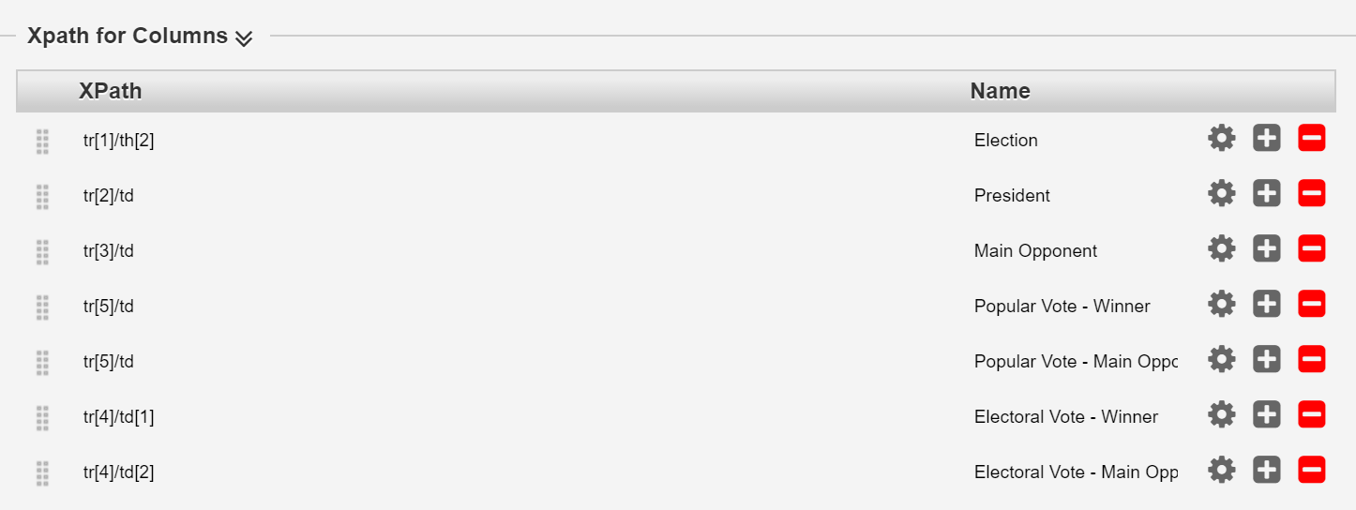Figure1

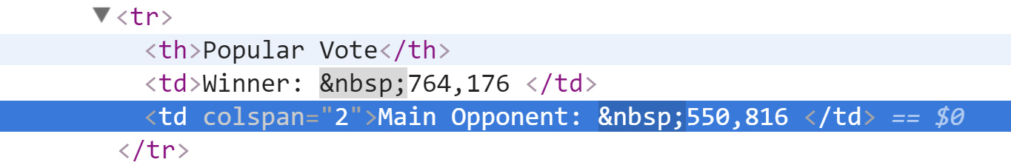Figure2

Also, notes that XPATH feature for Popular Vote Columns is an incorrect result from ‘colspan=”2”’ attribute. The detailed analysis of the markup structure offers a neat solution, which requires the database designers to change XPATH fields with attributes tr[5]/td as tr[5]/td[1] AND tr[5]/td[2] respectively.

* 1. *Localhost Data Wrap up Procedure*

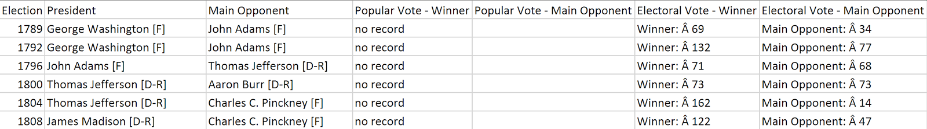

Figure3

The figure above represents part of the raw data after accomplishing procedure 1. This involves Election by year value, party information… etc. It is worth to note that Party Information is mixed up with candidate name. Hence, further clean up to this dataset is critical. In procedure 2, we applied an R script to this dataset aiming at column splitting and renaming.

Figure4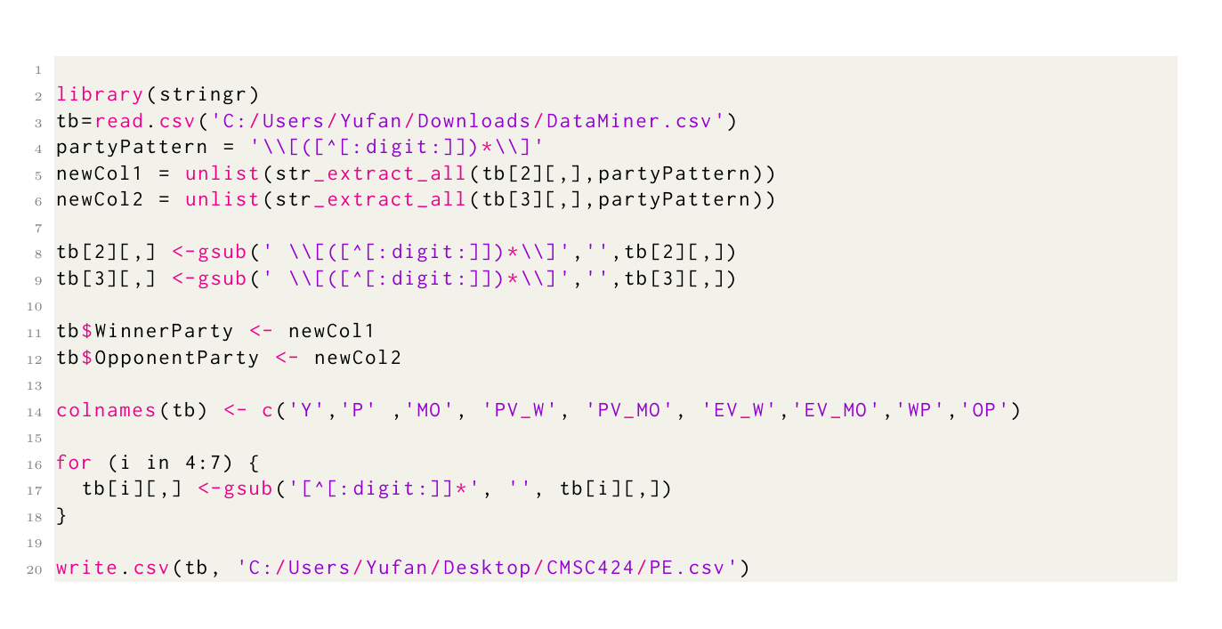

The selected file will then be processed and matches to the system requirement.

* 1. *Load Procedure*

A well-formatted CSV file will be used in this step such that the designers can load it to the PED located on the WAMP Server. Users can, therefore, query the relevant data to answer their pre-defined questions through a web interface.

1. **ER Model**

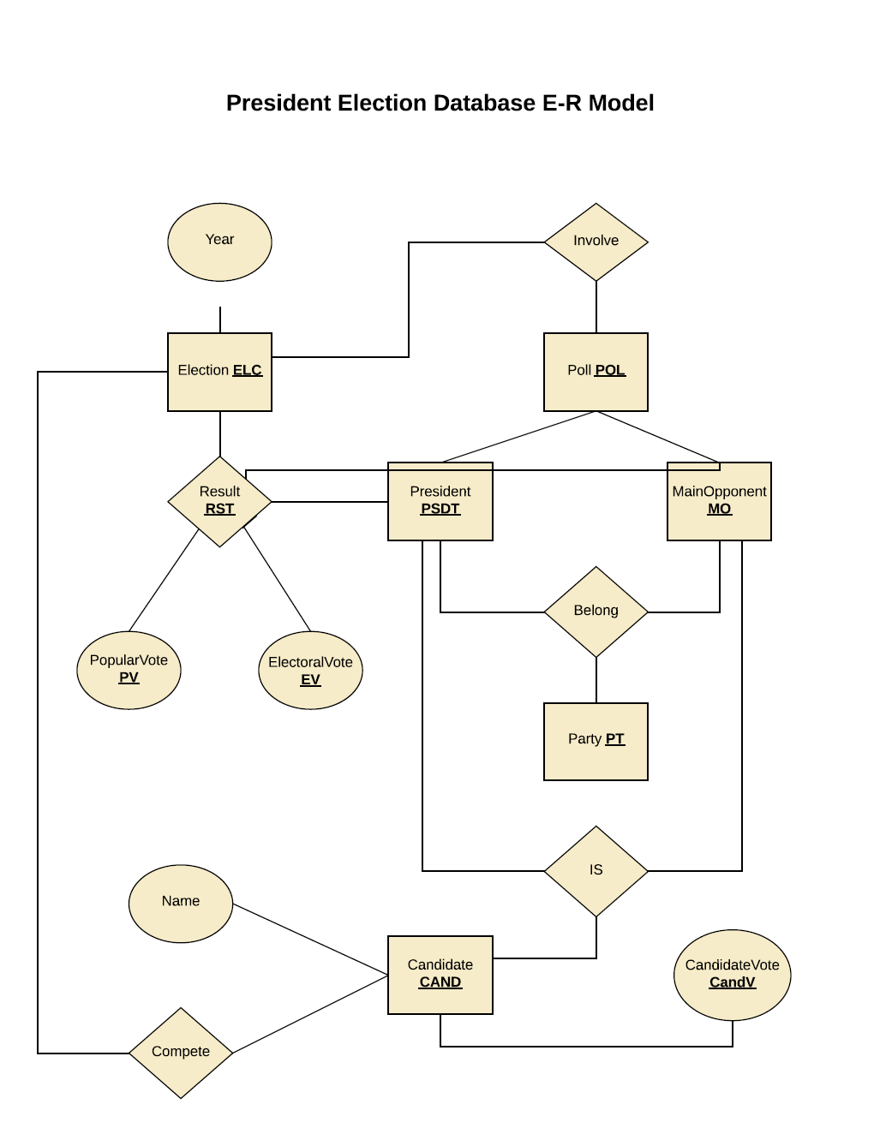

­

1. 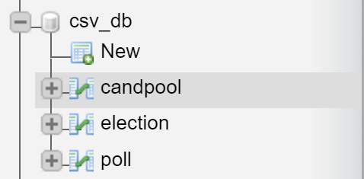**Relation Break down in BCNF Form**

The screenshot on the left is the complete relational schema of the PED.

Figure5: CandidatePool Relation

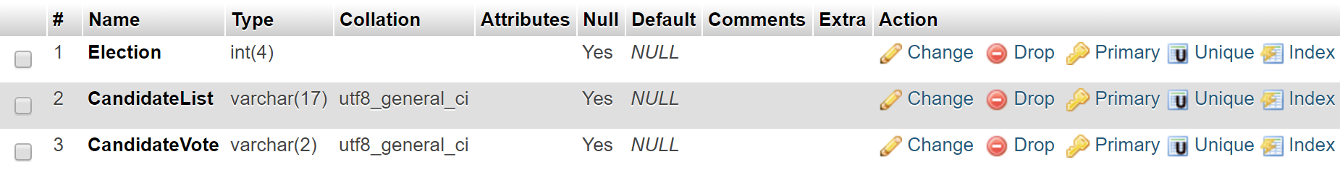

Figure6: ElectionResult Relation

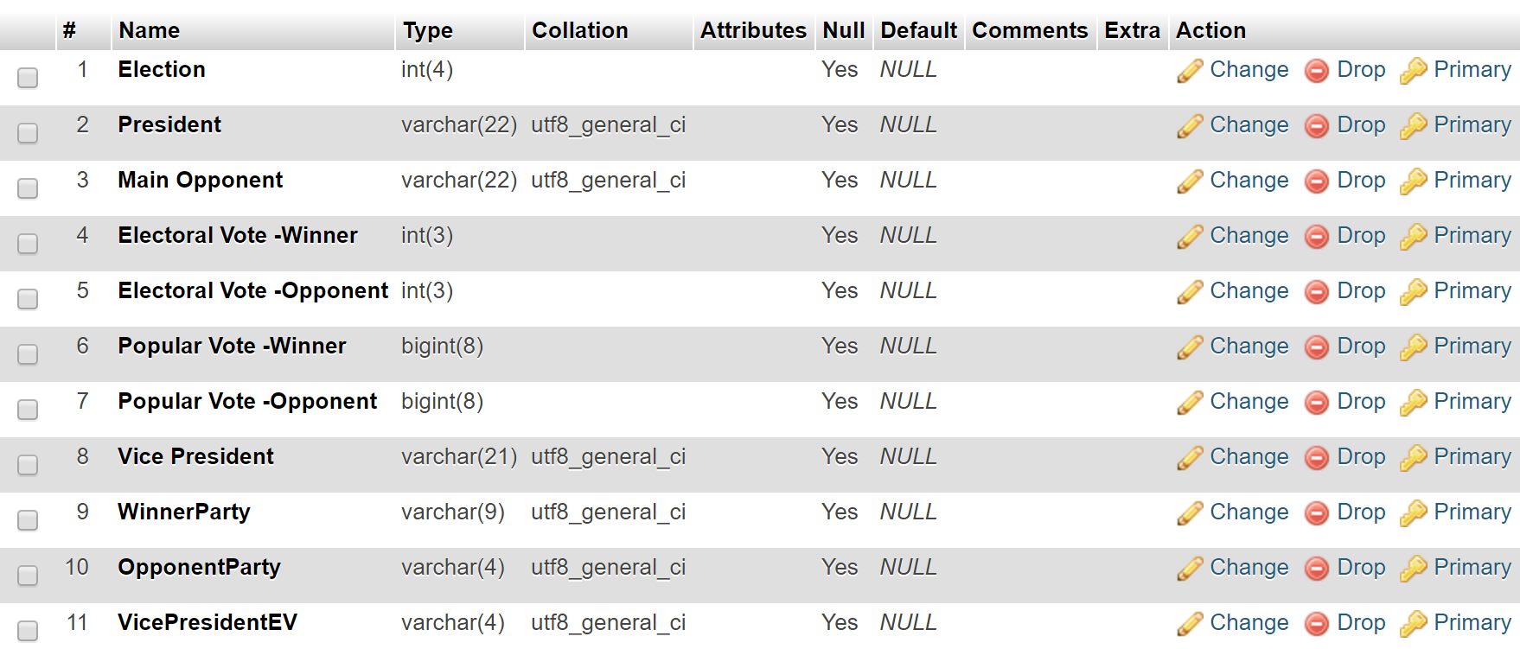

Figure7: PollResult Relation

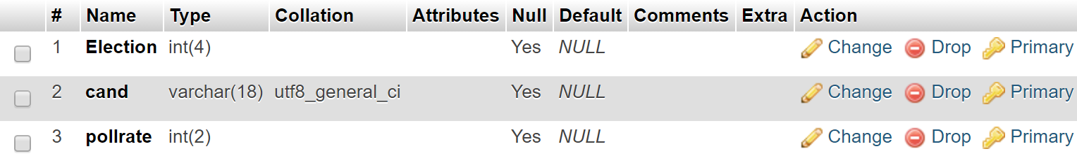

Through thorough analysis we decided break down the PED into three pieces. Any relation between these three tables are unrelated to the ones in the other table, and hence, this breakdown remove the redundancy and holds the lossless property.

1. **Task Emulation**

In this section, we aim to provide the pseudo SQL code that would be available to the users, which would be used later to connect PED with our webserver. Below we list our current available queries and their underlying SQL code respectively.

|  |
| --- |
| Query for a given Election Year  Election Year  President name  Main Opponent  Vice President  Party Affiliation  Poll Results |

SELECT `Election`,`President`,`MainOpponent`,`VicePresident`,

`WinnerParty`,`OpponentParty`, p1.pollrate, p2.pollrate

FROM `election` e1 join poll p1 using (election) join poll p2 using (election)

WHERE e1.president = p1.cand and e1.`Main Opponent` = p2.cand

LIMIT ".$limit

|  |
| --- |
| Query for a given President/Candidate  President name  Election Year  Main Opponent  Vice President  Party Affiliation |
| Candidate Name  Election Year  Candidate Electoral Vote |

SELECT `Election`,`President`,`Main Opponent`,`VicePresident`,

`WinnerParty`,`OpponentParty`

FROM `election`

WHERE `president` like '%" .$temp."%'

|  |
| --- |
| Query for Re-elected on non-contiguous times  President name  Term1  Term2 |

SELECT DISTINCT e1.President, e1.Election, e2.Election

FROM election e1, election e2

WHERE e1.President = e2.President and (e1.Election - e2.Election > 4) and

e1.President like '%".$temp."%'

|  |
| --- |
| Query for Swing Candidates  Election Year1  Election Year2  President/MainOpponent name  Party Affiliation of Year1  Party Affiliation of Year2  Election Result of Year1  Election Result of Year2 |

SELECT e1.Election, e2.Election, e1.President, e1.WinnerParty, e2.WinnerParty

FROM election e1, election e2

WHERE e1 and e2 are not in the same party AND e1 and e2 have the same name

AND (e1 is president, e2 is main opponent OR

e1 is president, e2 is president OR

e1 is main opponent, e2 is main opponent)

|  |
| --- |
| Party Historical Query  Party Name  Electoral Vote  Party Vote  Win Counts |

SELECT WinnerParty as Party, SUM(`Electoral Vote -Winner`) as EV,

SUM(`Popular Vote -Winner`) as PV, count(WinnerParty)

FROM `election`".$where.

Group by WinnerParty

ORDER BY SUM(`Electoral Vote -Winner`) DESC

|  |
| --- |
| Third Party Candidate Info Query  Election  Name  Party  Election Result |

(SELECT election, President as name, WinnerParty as party, TRUE

FROM `election` e1

WHERE e1.WinnerParty != 'D' and e1.WinnerParty != 'R'

) UNION (

SELECT election, President as name, OpponentParty as party, FALSE

FROM `election` e1

WHERE e1.OpponentParty != 'D' and e1.OpponentParty != 'R'

)

|  |
| --- |
| Most Popular Candidate Query  Year  Name  Popular Vote Number  Party Affiliation |

SELECT election, President, `Popular Vote -Winner`, WinnerParty

FROM `election`

ORDER BY `Popular Vote -Winner` DESC

LIMIT ".$temp

|  |
| --- |
| Lost Poll But Won Election Query  Year  President Name  President Poll Rate  Opponent Name  Opponent Poll Rate |

SELECT p1.Election, e1.President, p1.pollrate, p2.cand, p2.pollrate

FROM poll p2, election e1 join poll p1 USING (election)

WHERE e1.President = p1.cand and

p2.Election = e1.Election and

p2.cand != e1.President and

p2.pollrate >= p1.pollrate

1. **Progress Report on Web Server Build up**

We used Amazon EC2 instance to set up a remote server such that anyone can access this host from the branch http:/yufangfeng/phpmyadmin.

Mysql and PHPMyAdmin for database management are installed on this server along with the WAMP sever. Currently designers can import the local data files into the server and build up their own queries under the SQL tab. We plan to set up a wrapper for this database server so that users who visit our server can extract information interested in by choosing or entering input without writing MySQL code.

Figure8: Import Tab Screenshot

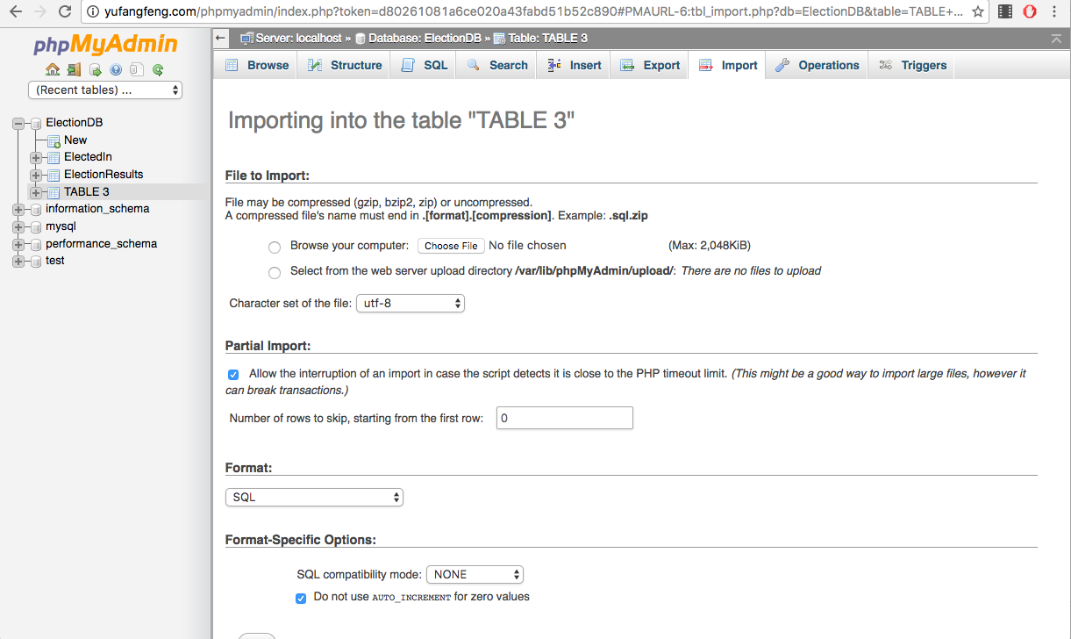

Figure9: PHPmyAdmin Login Page

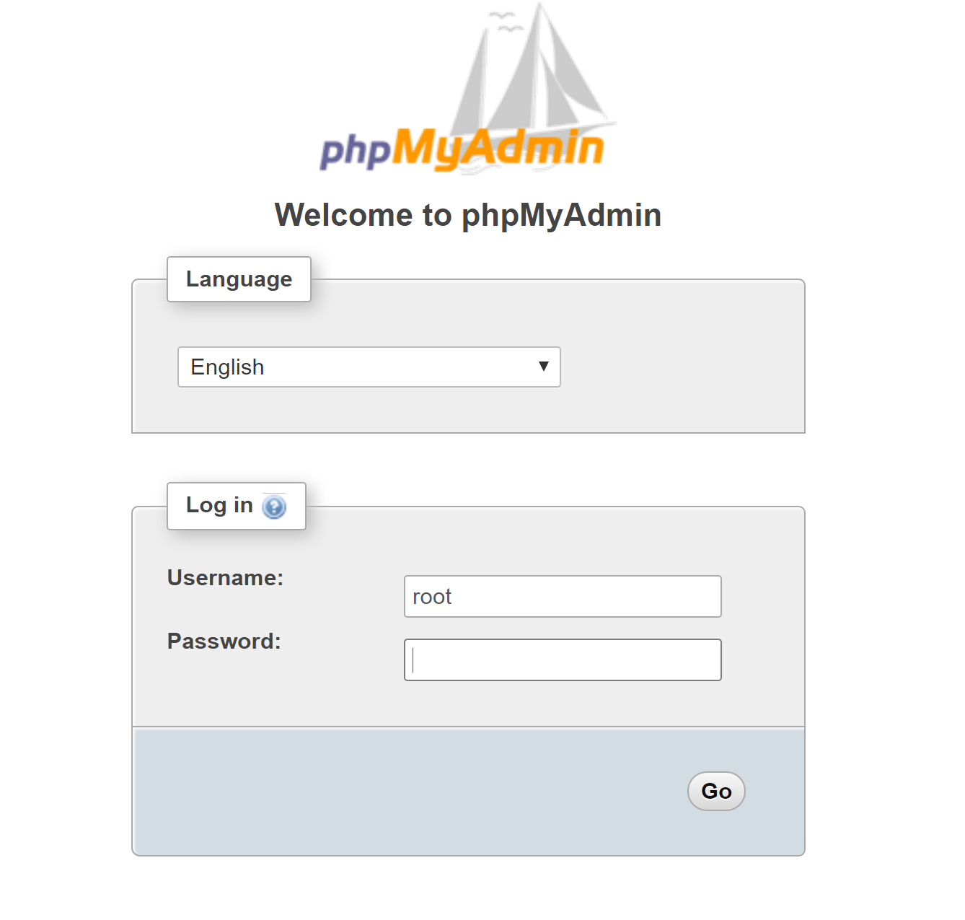

1. **Interactive User Interface**

In PhaseIII, I implemented a User Interface build upon PHP, HTML, CSS, and a small portion of JQuery, so that user can search for a limited set of data without modifying the dataset.

Figure10: Screenshot of the user interface

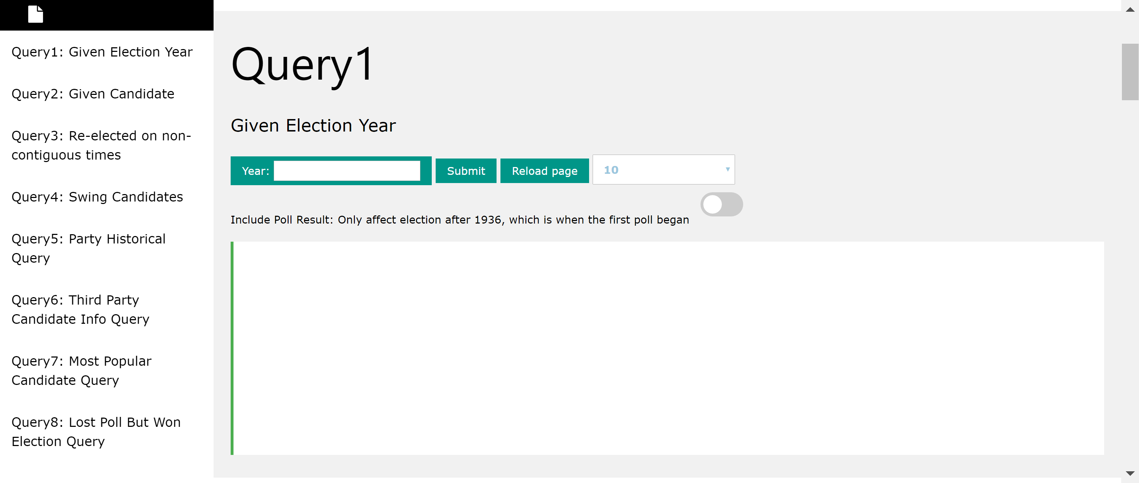

1. **User Manual**

**PAGE LAYOUT:**

There is a navigation bar at the left-hand side, users can jump to the location of a certain query by clicking on the html anchors at the side bar.

All queries are listed in one page. There is a title refers to the purpose for each query; a submit button used to activate required search; numerous optional buttons for users to customize their own queries; and a text box below each query used to display corresponding results.

**Query1**

For Query1, while providing some basic functionalities of this query, I also granted the public users the permission to modify their query in a reasonable and restricted way.

INPUT:

1. The election year to be searched for
2. Dropdown list with value indicating number of maximum results allowed to be shown in the text box
3. A scrolling button to switch between POLL/NO POLL forms. I designed this functionality because of the inconsistency of the dataset. The election relation table contains presidential election data from 1789-2016, while the polling results were not available until 1936. Users can access more detailed results starting from 1936 by choosing the POLL form, or access a less comprehensive dataset ranging from 1789-1936.

OUTPUT:

1. Option info
2. Number of rows returned
3. A table required by the query

**Query2**

For Query2, I allowed the public users to search for a given candidate/president using his/her partial name.

(e.g ‘George’ for ‘George Bush’ and ‘George Washington’)

INPUT:

1. The candidate/president name to be searched for
2. A scrolling button to switch between PRESIDENT/CANDIDATE forms. I separated all candidates into two parts. The PRESIDENT part represents all major candidates, e.g. President and the Main Opponent of that President. The CANDIDATE part contains limited info about those less competitive candidates.

OUTPUT:

1. Option info
2. Number of rows returned
3. A table required by the query

**Query3**

For Query2, I allowed the public users to search for a given candidate/president using his/her partial name.

(e.g ‘George’ for ‘George Bush’ and ‘George Washington’)

INPUT:

1. The candidate/president name to be searched for

OUTPUT:

1. Number of rows returned
2. A table required by the query

**Query4**

INPUT:

NONE

OUTPUT:

1. Number of rows returned
2. A table required by the query

**Query5**

INPUT:

1. Party Key – A party key legend is provided for users’ convenience.

OUTPUT:

1. Number of rows returned
2. A table required by the query

**Query6**

INPUT:

NONE

OUTPUT:

1. Number of rows returned
2. A table required by the query

**Query7**

INPUT:

1. A number represents maximum number of results to be listed in the text box

OUTPUT:

1. Number of rows returned
2. A table required by the query

**Query8**

INPUT:

NONE

OUTPUT:

1. Number of rows returned
2. A table required by the query

**Data Insertion**

To insert new data to this dataset, users need to have an authorized account provided by the database manager. After being granted, they can sign in to **whateverhostitis/phpmyadmin** to manage the database from a backend perspective.

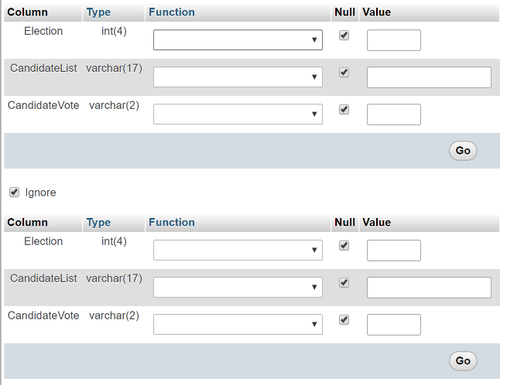**Figure12** on the left shows that users can insert new data to the ‘**candpool**’ table.

1. **Limitations and possible improvements**

Though the PED that I implemented works well in different scenarios, it also has lots of limitations. For example, the data source merely comes from archive.gov and Wikipedia, while the formats of these sites are not in consistent with each other.

Case1: Poll result in Wikipedia includes the party affiliations of some of the candidates, however, it also omits the party affiliations of some candidates. Therefore, I have to delete the PA information from the Poll result dataset.

Case2: The electoral college provides very comprehensive data about historical U.S presidential election result. However, the information of some less competitive candidates is incomplete. Therefore, I have to separate the dataset into two pieces – one for strong candidates with complete information and one for weak candidates with merely electoral votes.

The PED would be more comprehensive and could provide more insights to the users if the data source could be kept in a more consistent and complete manner.